**Estimated time to complete this lab: 10 minutes. Please follow the instructions to complete the hands-on. Each instruction expects a command for the Git Bash. 1. Verify if master is in clean state. 2. List out all the available branches. 3. Pull the remote git repository to the master 4. Push the changes, which are pending from “Git-T03-HOL_002” to the remote repository. 5. Observe if the changes are reflected in the remote repository**

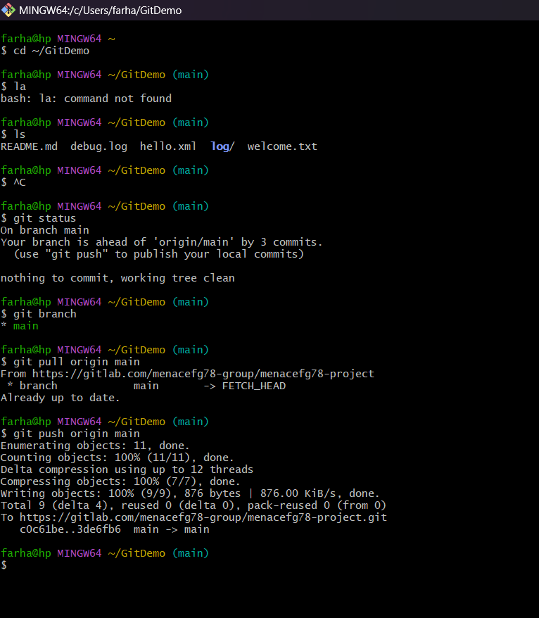**Code:**

**Code text:**

farha@hp MINGW64 ~

$ cd ~/GitDemo

farha@hp MINGW64 ~/GitDemo (main)

$ la

bash: la: command not found

farha@hp MINGW64 ~/GitDemo (main)

$ ls

README.md debug.log hello.xml **log**/ welcome.txt

farha@hp MINGW64 ~/GitDemo (main)

$ ^C

farha@hp MINGW64 ~/GitDemo (main)

$ git status

On branch main

Your branch is ahead of 'origin/main' by 3 commits.

(use "git push" to publish your local commits)

nothing to commit, working tree clean

farha@hp MINGW64 ~/GitDemo (main)

$ git branch

* main

farha@hp MINGW64 ~/GitDemo (main)

$ git pull origin main

From https://gitlab.com/menacefg78-group/menacefg78-project

* branch main -> FETCH_HEAD

Already up to date.

farha@hp MINGW64 ~/GitDemo (main)

$ git push origin main

Enumerating objects: 11, done.

Counting objects: 100% (11/11), done.

Delta compression using up to 12 threads

Compressing objects: 100% (7/7), done.

Writing objects: 100% (9/9), 876 bytes | 876.00 KiB/s, done.

Total 9 (delta 4), reused 0 (delta 0), pack-reused 0 (from 0)

To https://gitlab.com/menacefg78-group/menacefg78-project.git

c0c61be..3de6fb6 main -> main

farha@hp MINGW64 ~/GitDemo (main)

$

**Output:**

**Cleaned up my Git repo**

**Ensured no unwanted files were pushed**

**Synced everything with GitLab**

**Verified it visually from the browser**

